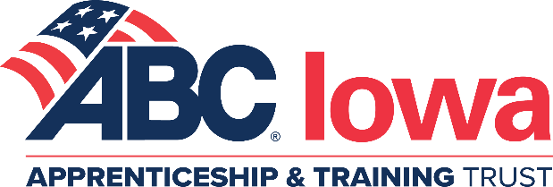

2023-2024 HVAC/PLUMBING/SHEET METAL REGISTRATION FORM - Evening Classes
(There will be staggered class times starting from 5:00-5:30pm and ending 9:00-9:30pm)

Company Name:
Company Education Contact:
Phone: - - E-mail Address:
Class Locations:
G – Grimes HVAC, Plumbing & Sheet Metal
H – Hiawatha HVAC ONLY Levels 1, 2 & 3 (**not guaranteed)
** If we don’t get the minimum number of people registered for the Hiawatha HVAC classes, the 2nd option would be Grimes.

Apprentice Name Level Location Trade

If anyone listed above requires an ADA accessible classroom, please list their name(s) here: __________________________________________________________________________________
Students will not be registered until payment is received in full! This is your invoice.

Enrollment fee for new or de-registered apprentice (Non-refundable) per student $175.00 x = $
Book fee (Every apprentice is required to purchase a new book from ABC) per student $200.00 x = $
Evening Yearly Tuition per student: If registering in Department of Labor $940.00 x = $
Not registering in Department of Labor $1,240.00 x = $
* FALL REGISTRATIONS ARE DUE AUGUST 9, 2023
For fall registrations received after August 9th add late fees - per student $100.00 x = $
TOTAL $

I acknowledge that I have read and understand the Payment Terms and Refund Policy.

Check Enclosed (Payable to ABC of Iowa Apprenticeship and Training Trust)
Credit Card Payment Visa MasterCard Discover AmEx
Name on Card: Exp. Date:
Card#: Security Code Zip code of cardholder:
Receipt needed

I would like to donate an additional $ for the 2023-2024 Craft Championships Competition
ABC of Iowa Apprenticeship and Training Trust reserves the right to cancel classes or to make changes in location/format as needed.

